**IOT LAB**

**Program No - 9**

**Program Title – GAS SENSOR AND LED**

**Aim – To design a smart gas leakage indicator system.**

**Hardware Required-**

* Arduino Board
* Bread Board
* Gas sensor
* Resistor
* LED

**Circuit Diagram –**

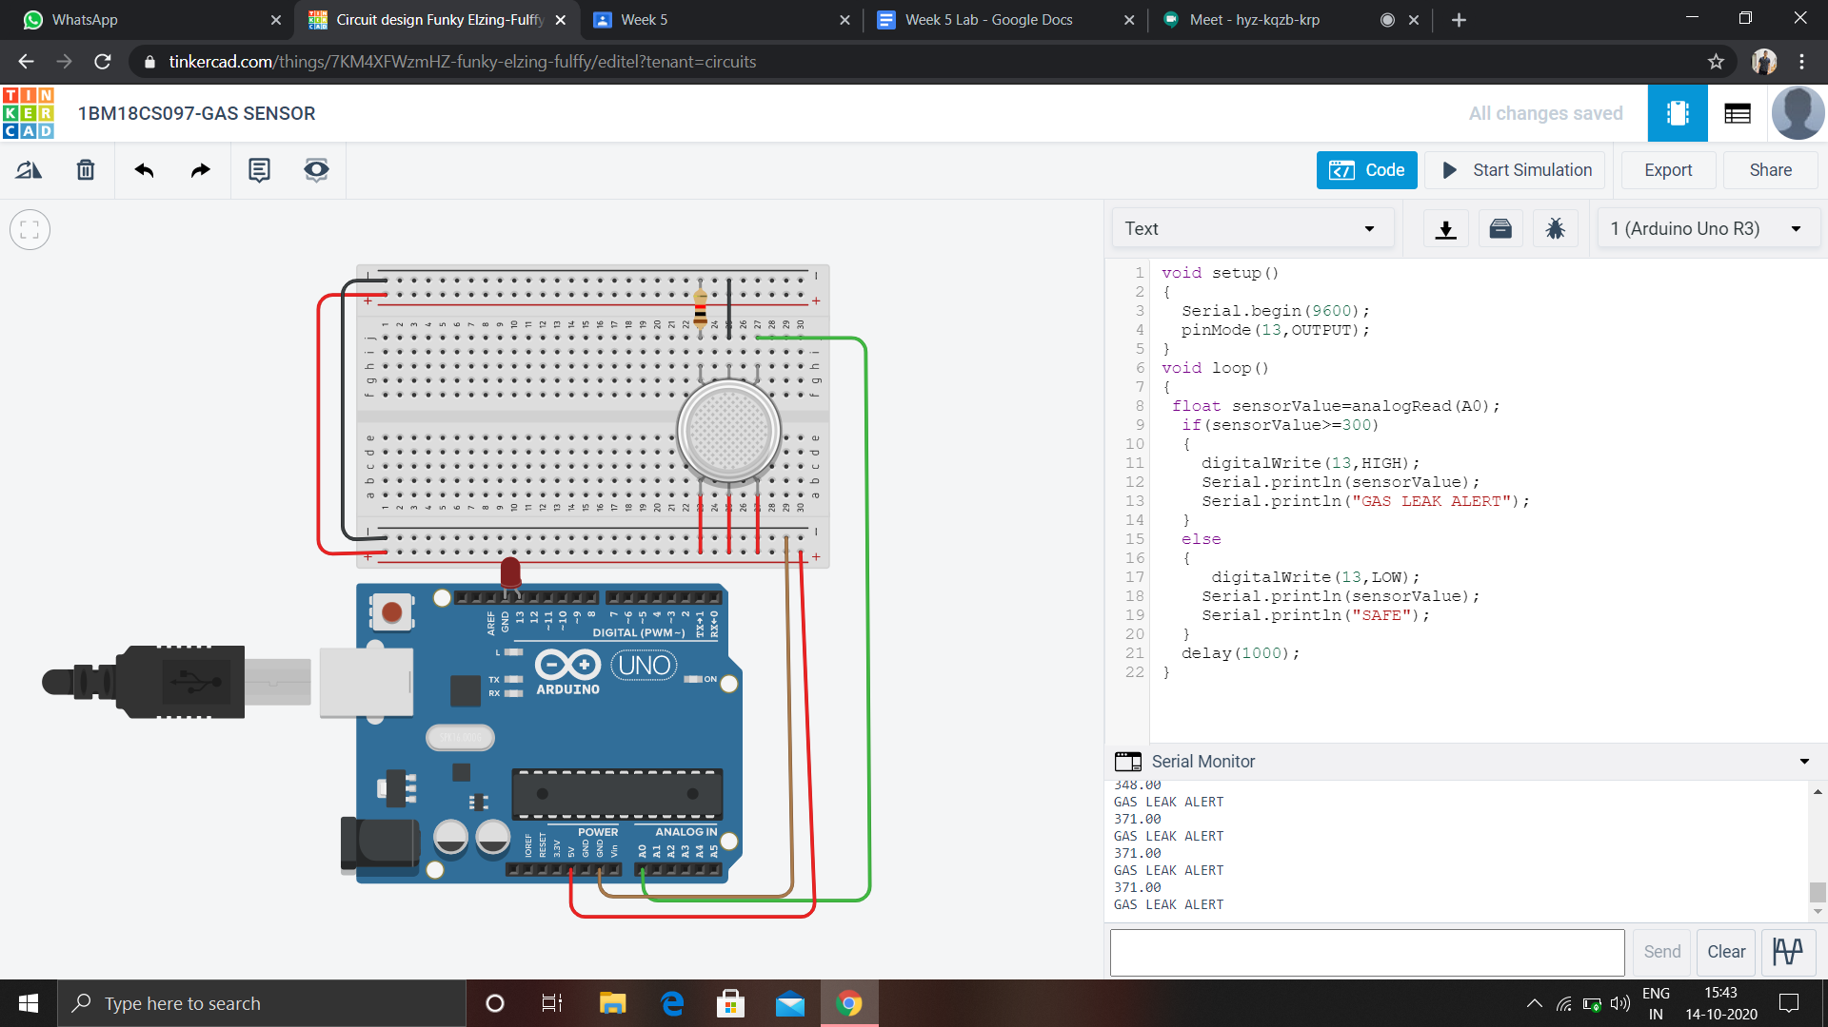

**Code –**

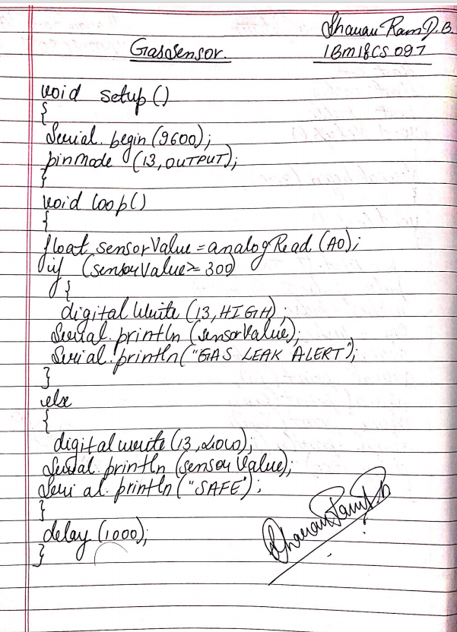

**Observation /Output-**

**The gas leakage can be detected with the help of LED.**